DAY-2



 PRESENTED BY:

* CH. ALEKHYA GAYATHRI
* E. HIMA BINDHU
* D. TRISHA
* A. HEMA
* I. MANISHA
* K. ASHWINI

TEAM LEADER: CH. ALEKHYA GAYATHRI

*WHY WE USE NUMPY AND PANDAS:

NUMPY: Numpy is a library which is used for perform advance mathematical calculations in python.

PANDAS: Pandas is a library which is used to access the data in present in the file.

* Pandas is power full python library used for data manipulation and data

analysis

*HOW TO CHECK INSTALLATION LIBRARY:

COMMAND PROMPT: pip list ---> which shows the library are related to python.

PROCESS:

* Open chrome and open google collab click on first link
* Open new notebook
* In upside one connected button and click it.
* CSV file is downloaded by data using numpy,pandas.
* Then open new notebook and add it in the new notebook.
* In right side open file select the folder and upload the session data
* And there we can see the file in screen in data CSV.
* Search the Kaggle and click it.
* Now we can start the coding with generative with AI

KAGGLE: So many data sets are available or not available in the website we have to check is known as Kaggle.

*WE HAVE TO IMPORT THE DATA SET IN COLAB NOTEBOOK:

step-1: we have to import the dataset in colab notebook

#we have to import pandas library

import pandas as pd #pd is a neck name for pandas

df=pd.read_csv('Data.csv')#df is a variable, read_csv is a predifined function from pandas package

type(df)

OUTPUT:

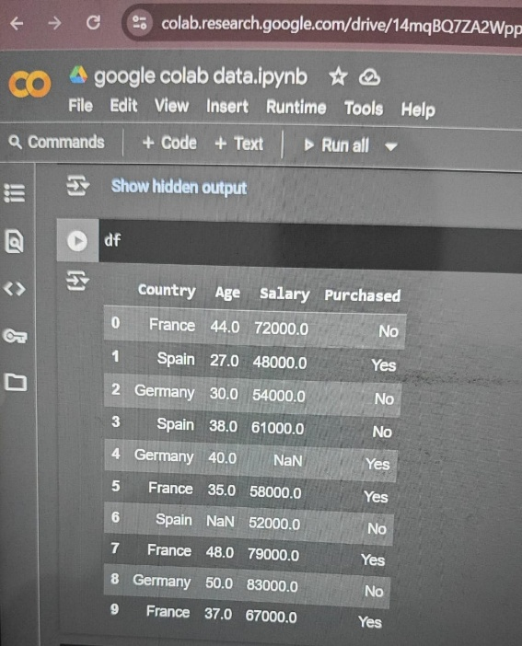

*GROUPING THE INPUT COLUMNS AND OUTPUT COLUMNS:

step-2:grouping the input columns and output columns

X=df.iloc[:,:-1]

OUTPUT:

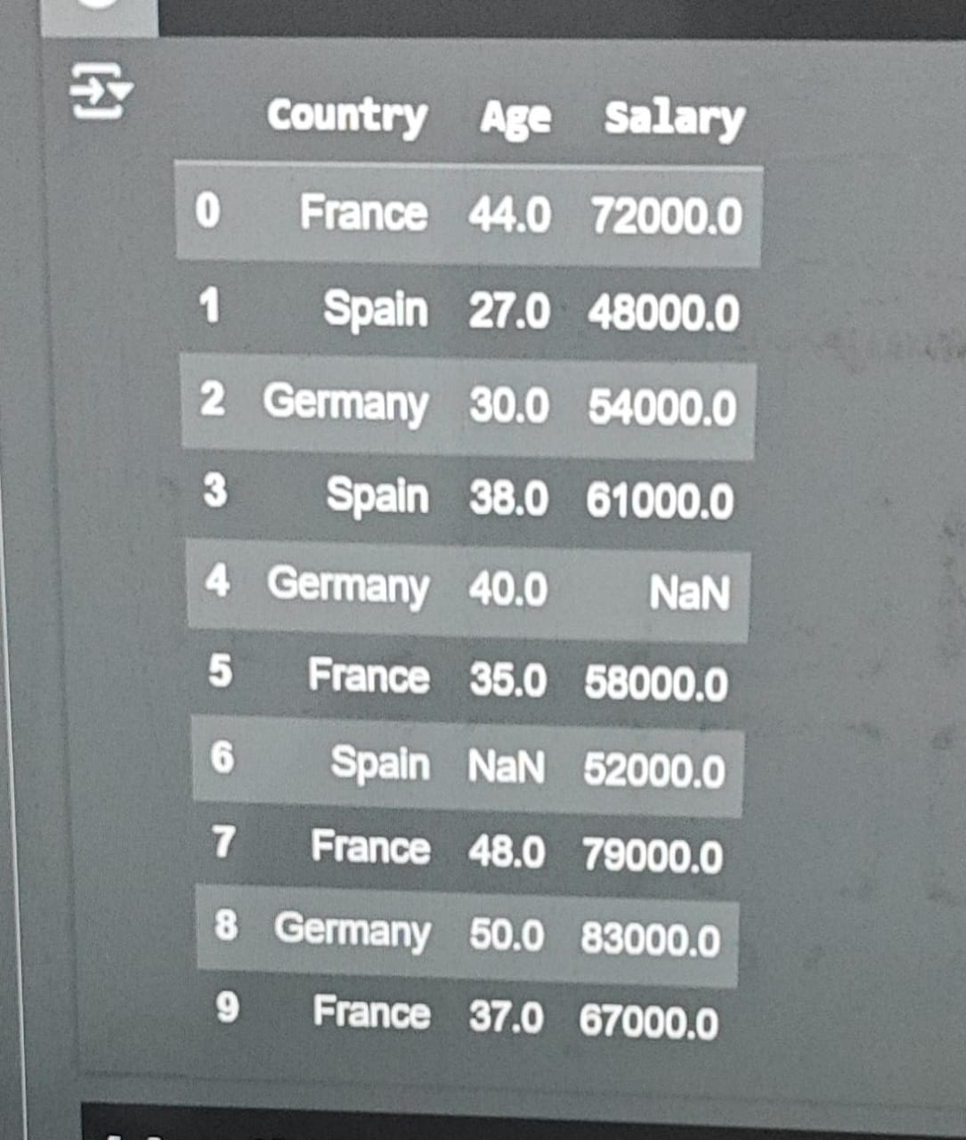

Y=df.iloc[:,-1]#slicing the output column

OUTPUT:

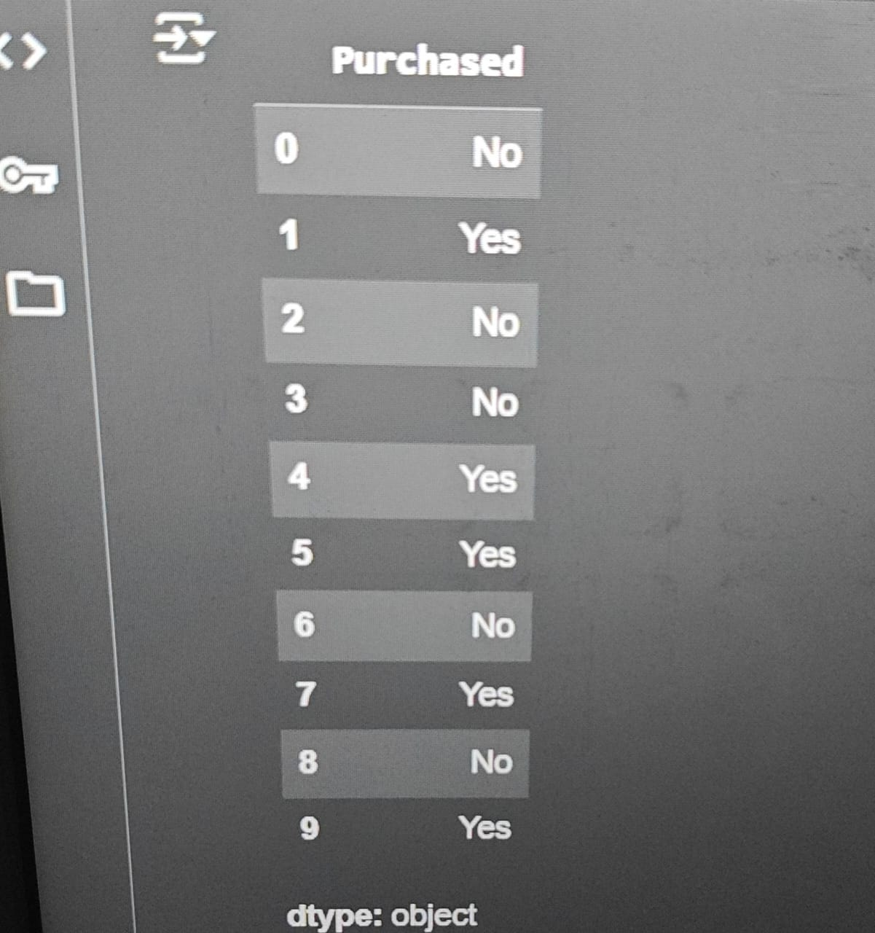

X=X.values

OUTPUT:

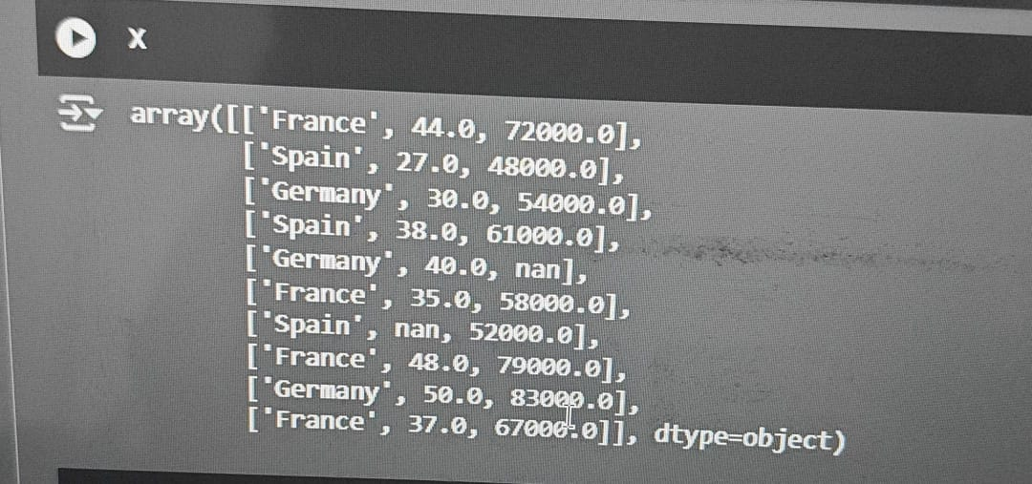

Y=Y.values

OUTPUT:

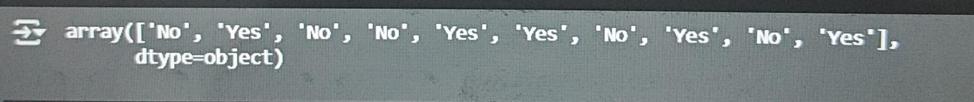

*HANDLING MISSING DATA OR VALUES:

#step-3:handling missing data or values

#scinario-1:#calculate mean or average of that column and replace the empty values

#scinario-2:#missing values in non numerical columns

#scinario-3:if we have missing values in huge data set ex:2 rows as empty values out of 2000

import numpy as np

from sklearn.impute import SimpleImputer #it is a class which was importing from sklearn.impute

imputer=SimpleImputer(missing_values=np.nan,strategy='mean')

imputer.fit(X[:,1:3])

X[:,1:3]=imputer.transform(X[:,1:3])#which performs the actions

*HANDLING THE CATEGORICAL DATA CONVERT THE CATEGORICAL DATA INTO NUMERIC DATA:

#step-4:handling the categorical data,convert the categorical data into numeric data

#which converts the text data into numeric data

from sklearn.preprocessing import OneHotEncoder #label encoder is a class from sk.preprocessing or libray

from sklearn.compose import ColumnTransformer #column transfromer is a class imported from sk.compose

#column transformer is uesd to apply changes of numerical data into categorical data

ct=ColumnTransformer(transformers=[('encoder',OneHotEncoder(),[0])],remainder='passthrough')#encoder is a method which converts text to binary

X=ct.fit_transform(X)

#onehot encoder is only used for inpuits

X

OUTPUT:

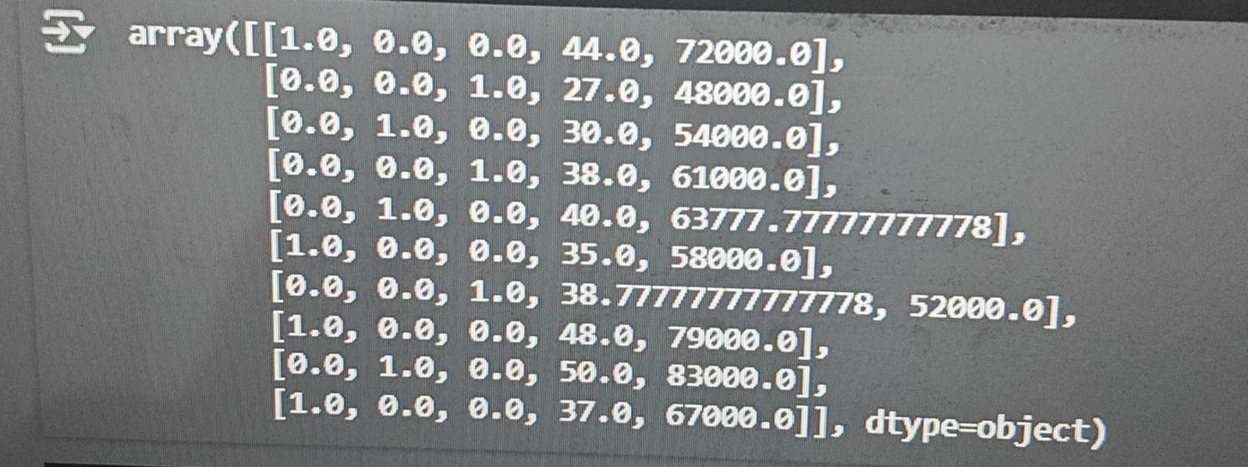

from sklearn.preprocessing import LabelEncoder

le=LabelEncoder()

Y=le.fit_transform(Y)

Y

OUTPUT:



*SPLIT THE DATA INTO TRAINING AND TESTING DATA:

#step-5:split the data into training and testing data

from sklearn.model_selection import train_test_split# it is a class which was imported from sklearn.model_selection

#it is was used for splitting the data for training and selecting the data

X_train,X_test,Y_train,Y_test=train_test_split(X,Y,test_size=0.2)

X_train

OUTPUT:

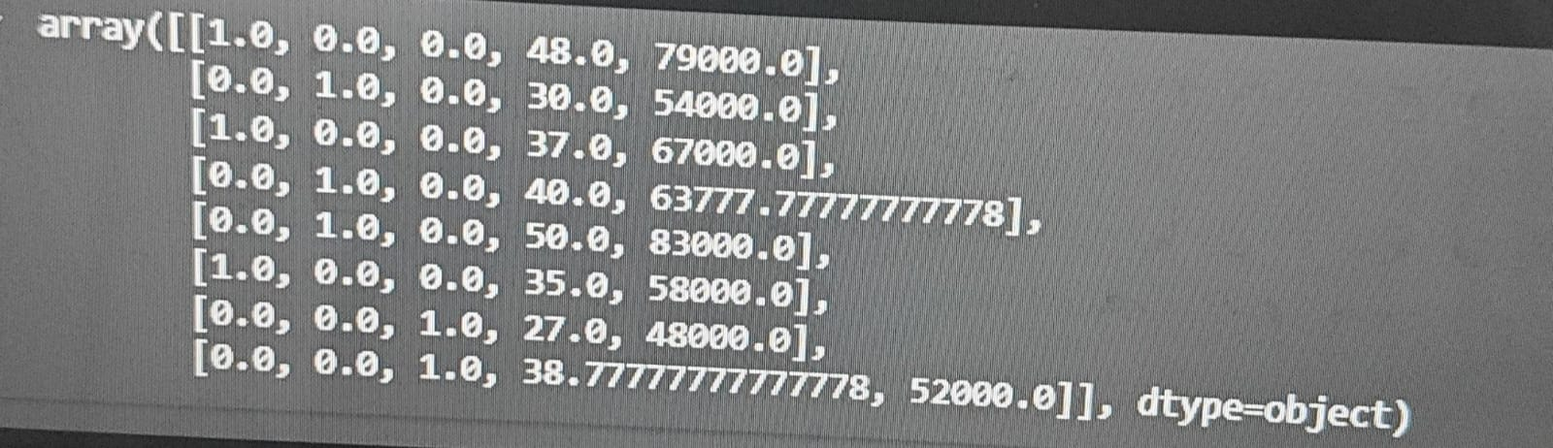

X_test

OUTPUT:

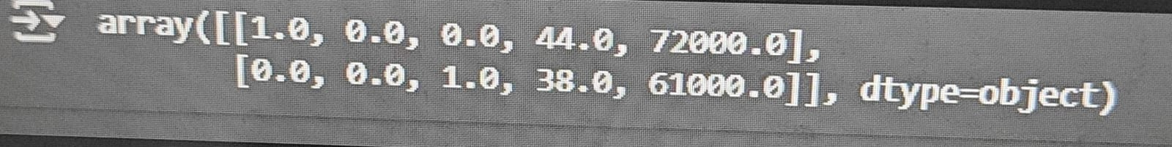

Y_train



Y_test



THANK YOU